## Determination of Silica in Wheat Leaves with ATR-FTIR-Chemometrics

## Abstract

Important crops such as wheat, barley, and rice accumulate silicon (Si), which contributes to the response of stress-relief mechanisms for environmental events such as drought and pathogen attack. Because of the importance of these crops, understanding the relationship between this element and plant science is the focus of numerous scientific efforts. Si quantification is a challenging and costly task, and destructive wet chemistry methods are commonly used. This study presents a non-destructive method for silicon determination in wheat leaves using attenuated total reflection infrared spectroscopy (ATR-FTIR) and chemometrics. Wheat (*Triticum aestivum*) was grown in a greenhouse under high (1.5 mM Na2SiO3) and low-Si supply (0.24 mM Si) conditions. The Si concentrations in leaves, pods, root, flag leaves, and inflorescence bracts at different growth stages were analyzed. The Si was quantified by inductively coupled plasma-optical emission spectroscopy elemental analysis (ICP-OES). A series of models based on multivariate ordinary least squares regression using varying sets of wave numbers selected by a genetic algorithm was built using baseline-corrected ATR-FTIR spectra. The models built with these sets showed a powerful correlation with the Si content determined by ICP-OES. The performance in prediction of each model was assessed using repeated k-fold cross-validation, showing a maximum error of prediction (RMSEP) of 0.1% wt. with minimum model complexity of four selected variables. However, a strong dependence on the matrix was noted when compared with other plant tissues.

## Introduction

The presence of silicon (Si) in plants contributes to the response of stress-relief mechanisms for environmental events such as drought and pathogen attack. Because of the importance of crops such as wheat, barley, rice, and other grasses that accumulate Si, understanding the relationship between this element and plant polymers has been the focus of numerous scientific efforts. Silicon is a soil constituent; therefore, plants invariably grow in Si-rich-environments (Epstein, 1994). In soil, Si is available in the form of silicic acid solutions. Some plants accumulate enough silicic acid that Si precipitates as silica, e.g., phytoliths. The accumulation occurs mainly in root endodermis, epidermal cells of both leaf and inflorescence bracts (Kumar et al., 2017), as well as awns and leaf macrohairs (Głazowska et al., 2018).

Something about IR and Silicon bands

Something about destructive methods to quantify silicon

The experiment was set-up to test the hypotesis that different silicon supplementation regimes have an effect on lignin content, quality or quatity. The experimental design was inspired by an article published in 1999 (Rafi and Epstein, 1999), in which four wheat plants were grown in a 100 ml tank containing 0.5 mM Na2SiO3. Si was absorbed by the plants until it was depleted in ca. 80 days. Another set of plants was grown in a Si-free environment with the same conditions; as there were no stressors, the Si-free plants grew normally. On day 80, some of the mature Si-free plants were transferred into a solution containing 0.5 mM Na2SiO3. The mature plants absorbed the same amount of Si in three days, as did plants grown in solutions to which Si had been added during their whole life. The experiment was set up both in a greenhouse and in a controlled growing chamber yielding the same result: plants deprived of Si avidly absorbed the element at maturity. In 2017, we set-up an experiment that included similar treatments: (1) A group of wheat plants was grown for 90 days in a solution containing 1.5 mM Na2SiO3 -- this group was called Si+; (2) a group (Si++) grown without Si until day 85, then 1.5 mM Na2SiO3 added to the tank; (3) a control group without silicon (Si-).

We could not find differences in lignin content, quality, or quatity. However, two interesting things were observed when we analyzed the data with chemometrics. (1) we could develop a fast and non-invasive method for silicon quantification using the ATR-FTIR spectra of the greenhouse-grown wheat leaves. (2) Using Principal Component Analysis (PCA) of the ATR-FTIR spectra, it was possible to distinguish samples from different parts of the plant and according to the silicon supply group.

**Material and Methods**

1. Plant growth and sampling

**Nutrient solution**: The nutrient solution was prepared according to a Standard Operational Procedure of the greenhouse at the University of Copenhagen in Rolighedsvej. In this procedure, commercial fertilizers are mixed in three different 250 L tanks with the formulations in Table 1. Then, an automatized pumping system mixes different ratios of the solutions in the tanks. The solutions are mixed with ozonized water which contained Si levels of 0.24±0.08 mM SiO2. For the experiment, ca.150 L of the nutrient solution was used weekly. The Si content was measured on every occasion with the method described below. Then, 1.5 mM Na2SiO3 was added to 50 or 100 L of solution (depending on the timeline) from a 30 mM stock solution diluted in dm-water, while the same amount of dm-water was added to the controls. The measured Si content after dilution was 1.5±0.16 mM. At the end of each week, another Si sampling was performed, and the concentrations were always above 0.6 mM, which ensures Si surplus. pH was adjusted to 6 using HCl or NaOH solutions.

Table 1. Nutrient solution



**Silicon measurements:** Dissolved silica was measured by heteropoly blue method using the Hach protocol 8186 and a DR/1900 spectrophotometer (HACH Company, Loveland, USA) as described by the manufacturer. A Si standard solution of 1.0 mg/L also from Hach (cat 110649) was used for calibration. Polypropylene volumetric flasks were used for dilution of samples to avoid Si contamination.

**Plant production:** Wheat seeds (JB Asano) were surface sterilized as follows. The seeds were immersed in 2.7% sodium hypochlorite solution (v/v) and a drop of Tween 80 for 30 minutes with constant stirring, then rinsed with MilliQ water five times (10 min each). The seeds were vernalized in the dark at 5°C in MilliQ water for four days. After that, the seeds were placed in Si-free oasis horticubes (Smithers-Oasis, Kent, Ohio). The cubes were soaked in 1/10 strength nutrient solution (adjusted to pH 5.5), and excess water drained. Each seed was placed directly into a wet cube. Once seeds started rooted and grew actively (4-7 days), they were left in a cold room for a vernalization period of 50 days.

After vernalization, the plants were cultured using the RainForest 72 aeroponic culture system (GHE, Fleurance, France), and placed in a greenhouse, mean temperature 20°C, under 9 h/15 h light (80–100 μE m−2 s−1)/dark regime. (Figure 1).

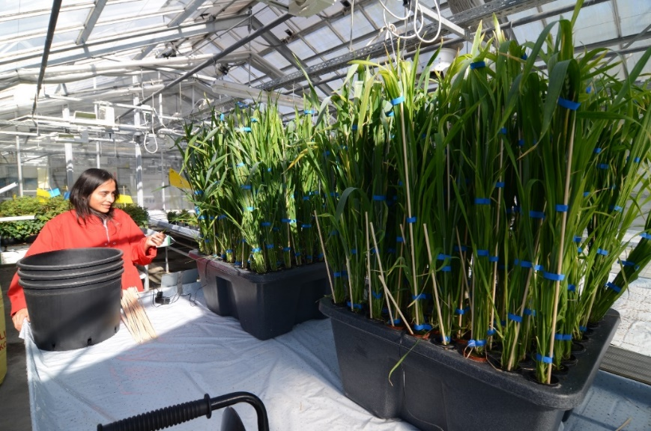

Figure 1. RainForest 72 aeroponic culture system (GHE, Fleurance, France) used to produce wheat plants in a greenhouse.

**Sampling:** Periodically, sample plants were harvested and divided between roots, pods, leaves, flag leaves, and inflorescence bracts according to the day of harvesting (Table 2).

Table 2. Plant parts harvested

|  |  |  |  |  |
| --- | --- | --- | --- | --- |
| **Plant Part** | **Days** | | | |
| **60** | **70** | **80** | **90** |
| Stem | X | X | X | X |
| Pods |  |  |  | X |
| Flag leaves |  |  |  | X |
| Leaves | X | X | X | X |
| Inflorescences | X | X | X | X |
| Roots | X | X | X | X |
| Grain |  |  |  | X |

The biomass was dried, ground, and extracted, using the option of *extensive solvent extraction method* published in (Mansfield et al., 2012). Briefly, the plant materias was air-dry until for 2–3 d at ambient temperature. Then, it was grinded in the mixing mill Retsch mm 400 with a frequency of 30 rpm for 2-3 minutes. Around 200–1,500 mg of plant material was addedto a 50-ml conical centrifuge tube. 30 ml of 50 mM NaCl was added vortexed. The solution was placed in a 4 °C refrigerator overnight. After centrifugation for 10 min at 2,800g at 1 °C, the solvent was removed by decanting. 40 ml of 80% ethanol was added. The samples was sonicated for 20 min, the mixture was centrifuge at 2,800g at 1 °C for 10 mimites. This step was repeated sucessively with 80% ethanol two additional times, 40 ml of 100% acetone, 40 ml of CHCl3/methanol (1:1), and 40 ml of 100% acetone. The material was freeze-dryed overnight, before the other analyzes were performed.

1. Chemical and chemometric analsys

**ATR-FTIR**: The spectra were recorded using a Thermo Fischer Scientific Nicolet 6700 FTIR spectrometer (Thermo Fischer Scientific, Waltham, MA, USA) equipped with a Goldengate ATR accessory (Specac Ltd, Orpington, Kent, UK). Spectra from 4000 to 600 cm−1 were obtained with a 4 cm−1 resolution, 200 background scans, and 100 scans for each sample spectrum. The average of the three spectra was calculated for each sample.

The ATR-FTIR spectra were analyzed in R (R core team, 2021, Version 4.0.5). The package hyperspec was used to perform baseline correction via the rubberband method (Hovde 2010, Beleites 2020). The package prospectr was used for spectra derivatization and smoothing (Wentzell and Brown, 2000), via savitzkyGolay function (Savitzky and Golay, 1964), the package factoextra to perform hierarchical.

**Elemental analysis:** Multi-elemental analyses of the solid samples was performed using inductively coupled plasma-optical emission spectroscopy (ICP-OES). A sample (10–50 mg) was mixed with 500–2500 μL 70% HNO3, 250–1000 μL 15% H2O2 and 40–200 μL 49% HF, and then digested in a pressurized microwave oven for 10 minutes with a starting pressure of 40 bar and a temperature of 240°C. After digestion, samples were diluted to a final 3.5% acid concentration with Milli-Q water before measurement on an ICP-OES (Model Optima 5300 DV, PerkinElmer) equipped with a HF-resistant sample introduction kit. For quantification, an external 10-point calibration standard P/N 4400-132565 and P/N 4400-ICP-MSCS (CPI International, Amsterdam) was used. A certified reference material (CRM) NCS 73013 Spinach leaf was analyzed together with the samples to evaluate the accuracy and precision of the analysis.

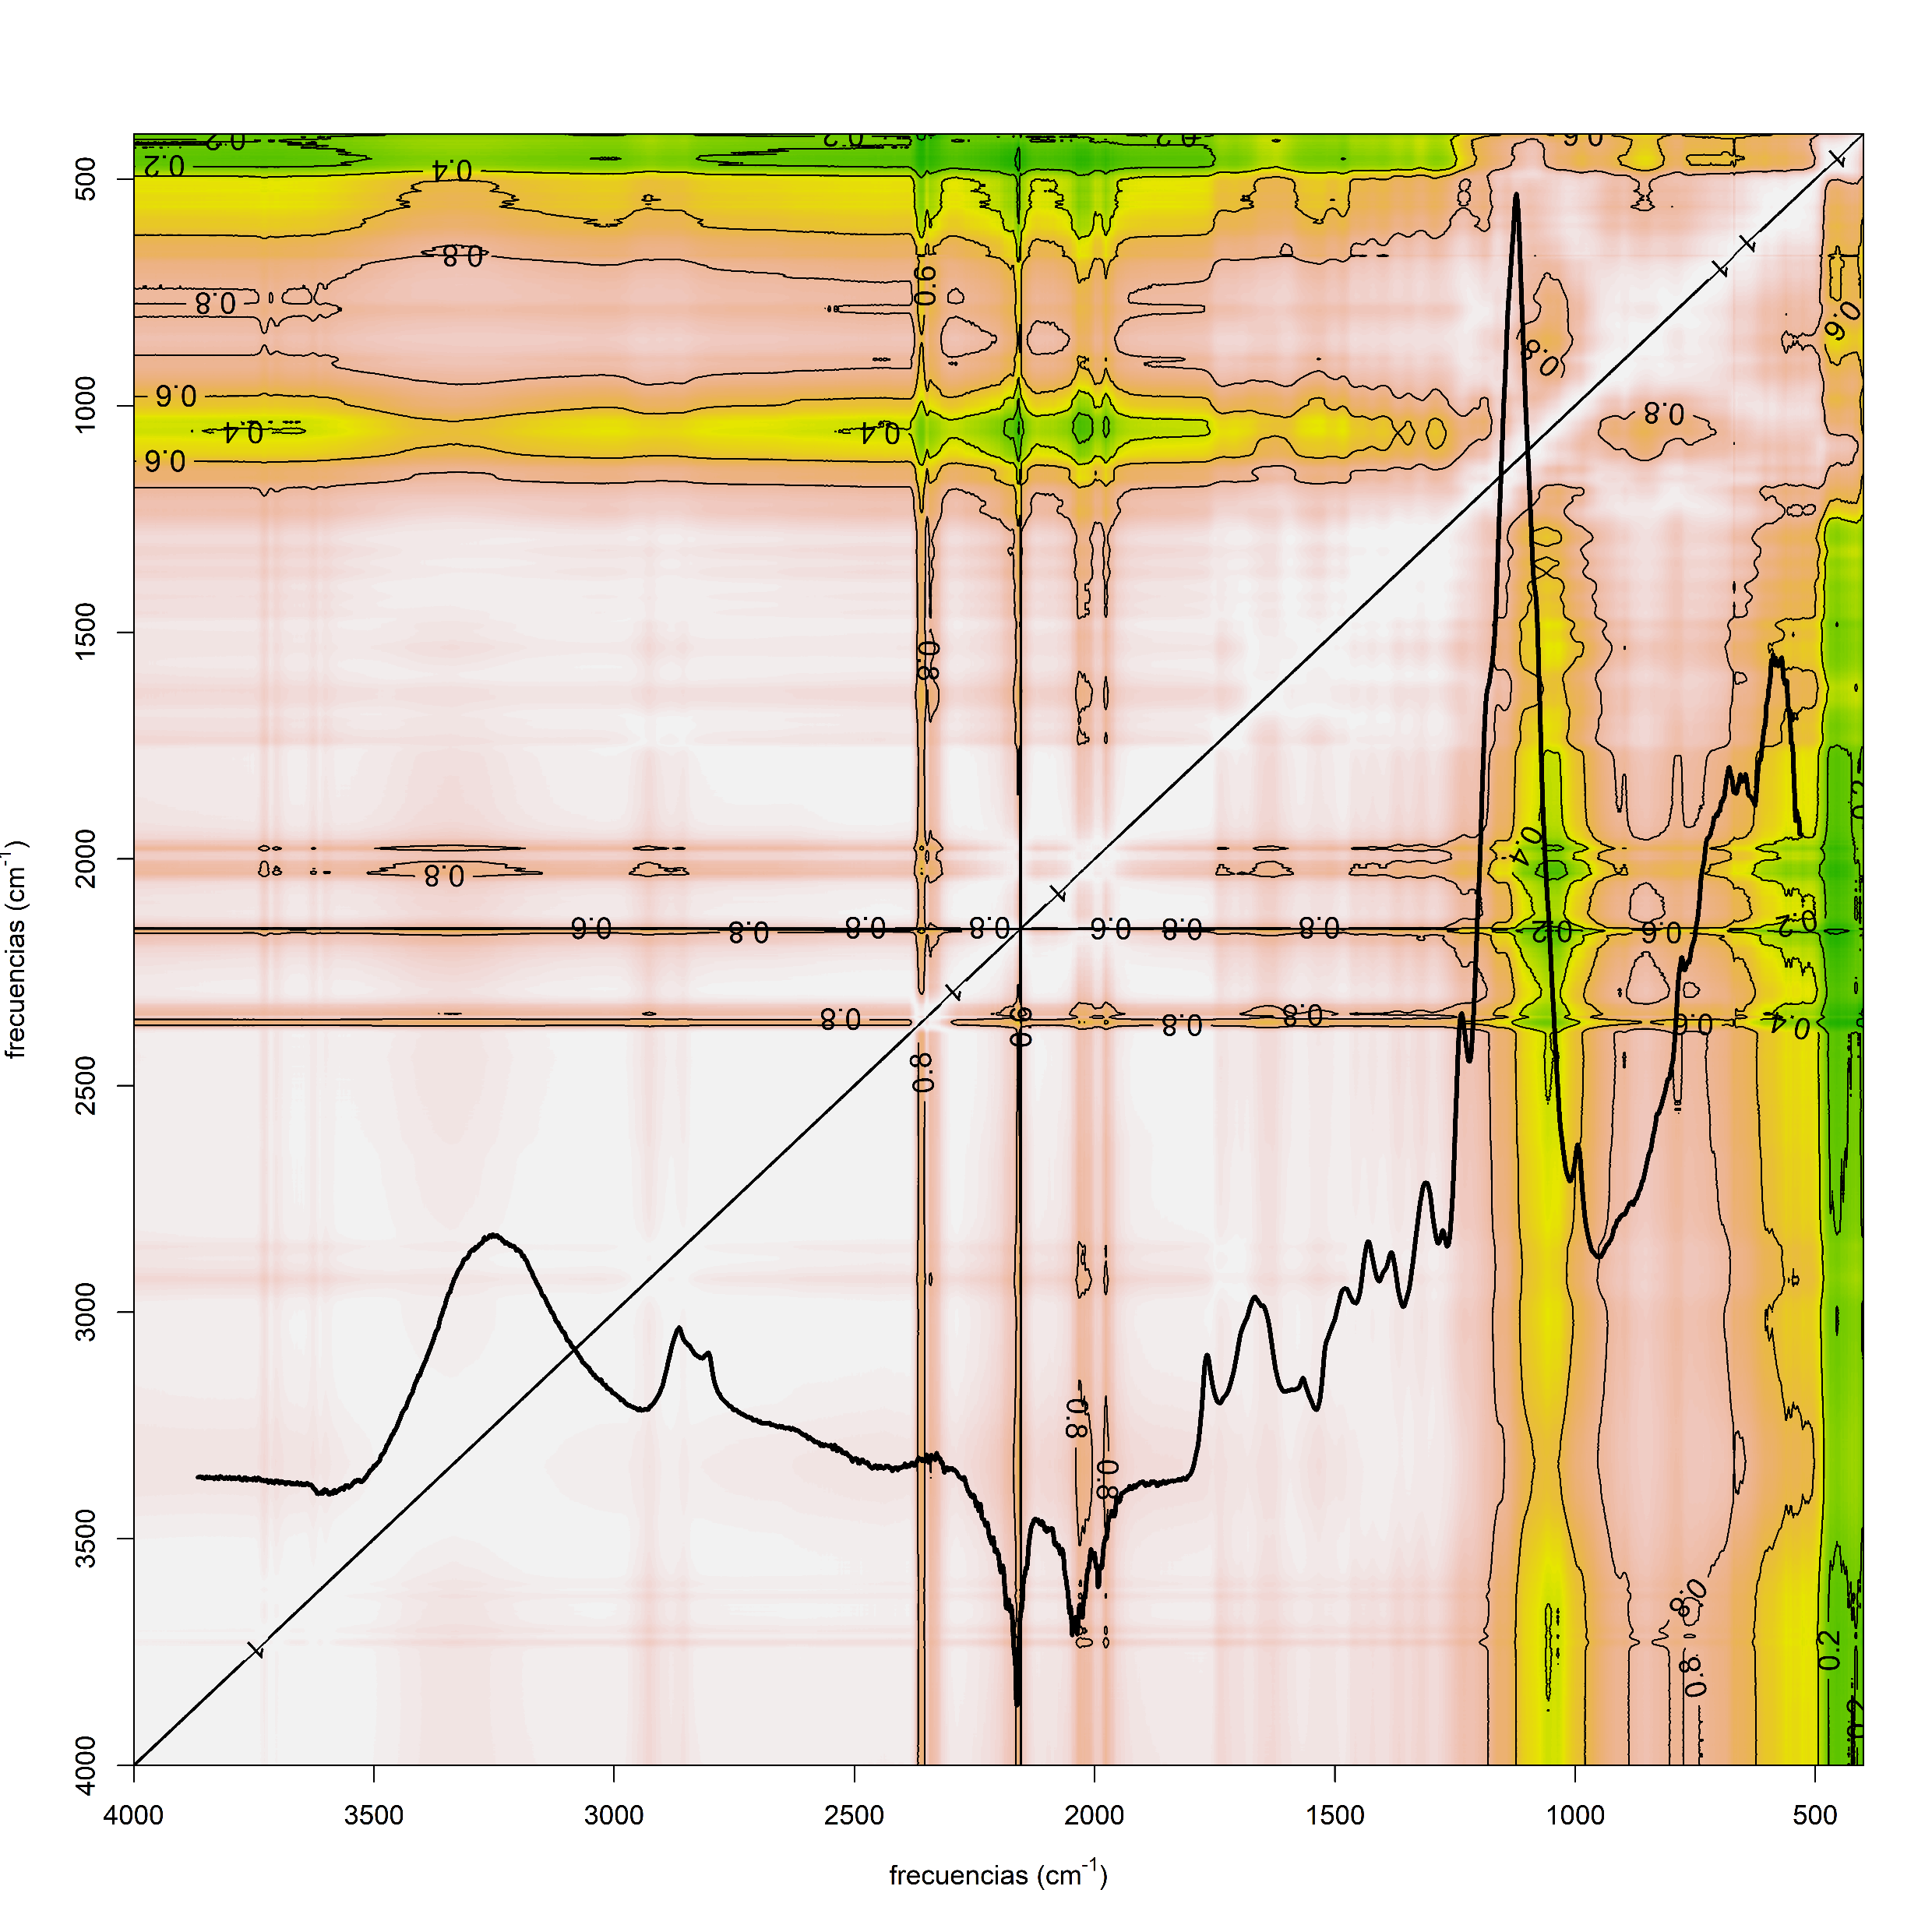**Results**

Puedes pegar las figuras des poster?

Estas sin la flecha amarilla.

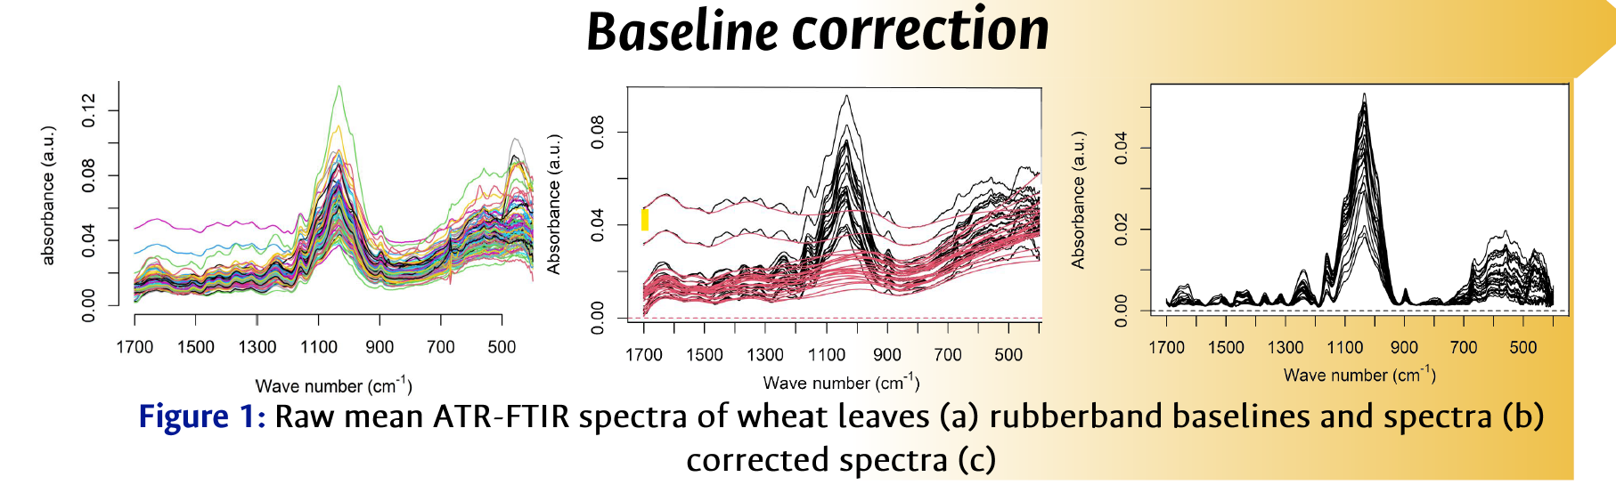

Estas 2 sin el verde, y sin el café-

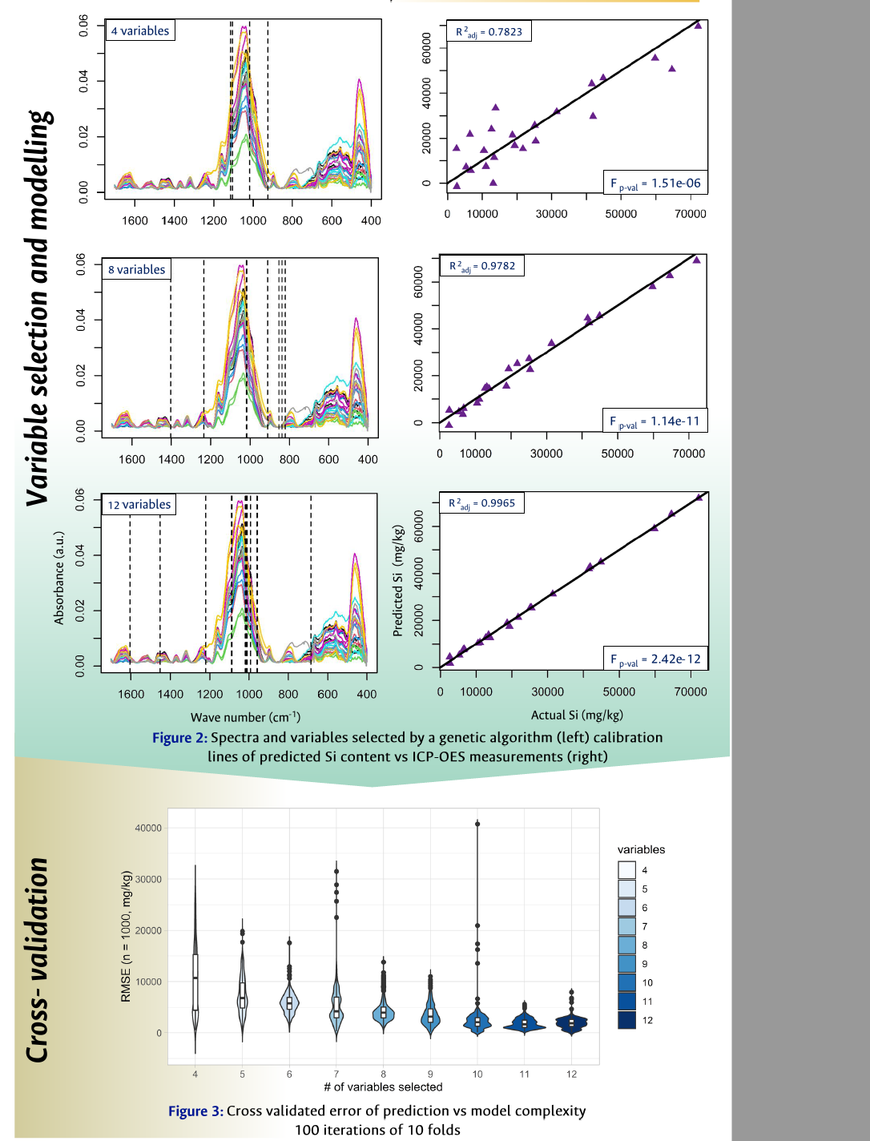

References

Brugiére, T., Exley, C., 2017. Callose-associated silica deposition in Arabidopsis. Journal of Trace Elements in Medicine and Biology 39, 86–90. https://doi.org/10.1016/j.jtemb.2016.08.005

Casey, W., Kinrade, S., Knight, C., Rains, D., Epstein, E., 2004. Aqueous silicate complexes in wheat, Triticum aestivum L. Plant, Cell & Environment 27, 51–54.

Epstein, E., 1994. The anomaly of silicon in plant biology. Proc Natl Acad Sci USA 91. https://doi.org/10.1073/pnas.91.1.11

Fang, J.-Y., Ma, X.-L., 2006. In vitro simulation studies of silica deposition induced by lignin from rice. Journal of Zhejiang University. Science. B 7, 267–271. https://doi.org/10.1631/jzus.2006.B0267

Głazowska, S., Murozuka, E., Persson, D.P., Castro, P.H., Schjoerring, J.K., 2018. Silicon affects seed development and leaf macrohair formation in Brachypodium distachyon. Physiologia Plantarum 163, 231–246. https://doi.org/10.1111/ppl.12675

Kumar, S., Soukup, M., Elbaum, R., 2017. Silicification in Grasses: Variation between Different Cell Types. Frontiers in Plant Science 8, 438. https://doi.org/10.3389/fpls.2017.00438

Law, C., Exley, C., 2011. New insight into silica deposition in horsetail (Equisetum arvense). BMC Plant Biology 11, 1–9. https://doi.org/10.1186/1471-2229-11-112

Mansfield, S.D., Kim, H., Lu, F., Ralph, J., 2012. Whole plant cell wall characterization using solution-state 2D NMR. Nat. Protocols 7, 1579–1589. https://doi.org/10.1038/nprot.2012.064

Rafi, M.M., Epstein, E., 1999. Silicon absorption by wheat (Triticum aestivum L.). Plant and Soil 211, 223–230.

Sluiter, A., Hames, B., Ruiz, R., Scarlata, C., Sluiter, J., Templeton, D., Crocker, D., 2008. Determination of structural carbohydrates and lignin in biomass. Laboratory analytical procedure 1617, 1–16.

Swedlund, P.J., Miskelly, G.M., McQuillan, A.J., 2009. An attenuated total reflectance IR study of silicic acid adsorbed onto a ferric oxyhydroxide surface. Geochimica et Cosmochimica Acta 73, 4199–4214. https://doi.org/10.1016/j.gca.2009.04.007

Trembath-Reichert, E., Wilson, J.P., McGlynn, S.E., Fischer, W.W., 2015. Four hundred million years of silica biomineralization in land plants. Proceedings of the National Academy of Sciences 112, 5449–5454.

Yamanaka, S., Sato, K., Ito, F., Komatsubara, S., Ohata, H., Yoshino, K., 2012. Roles of silica and lignin in horsetail (Equisetum hyemale), with special reference to mechanical properties. Journal of Applied Physics 111, 044703.

Zhang, C., Wang, L., Zhang, W., Zhang, F., 2013. Do lignification and silicification of the cell wall precede silicon deposition in the silica cell of the rice (Oryza sativa L.) leaf epidermis? Plant and soil 372, 137–149.

Zhang, J., Zou, W., Li, Y., Feng, Y., Zhang, H., Wu, Z., Tu, Y., Wang, Y., Cai, X., Peng, L., 2015. Silica distinctively affects cell wall features and lignocellulosic saccharification with large enhancement on biomass production in rice. Plant Science 239, 84–91. https://doi.org/10.1016/j.plantsci.2015.07.014